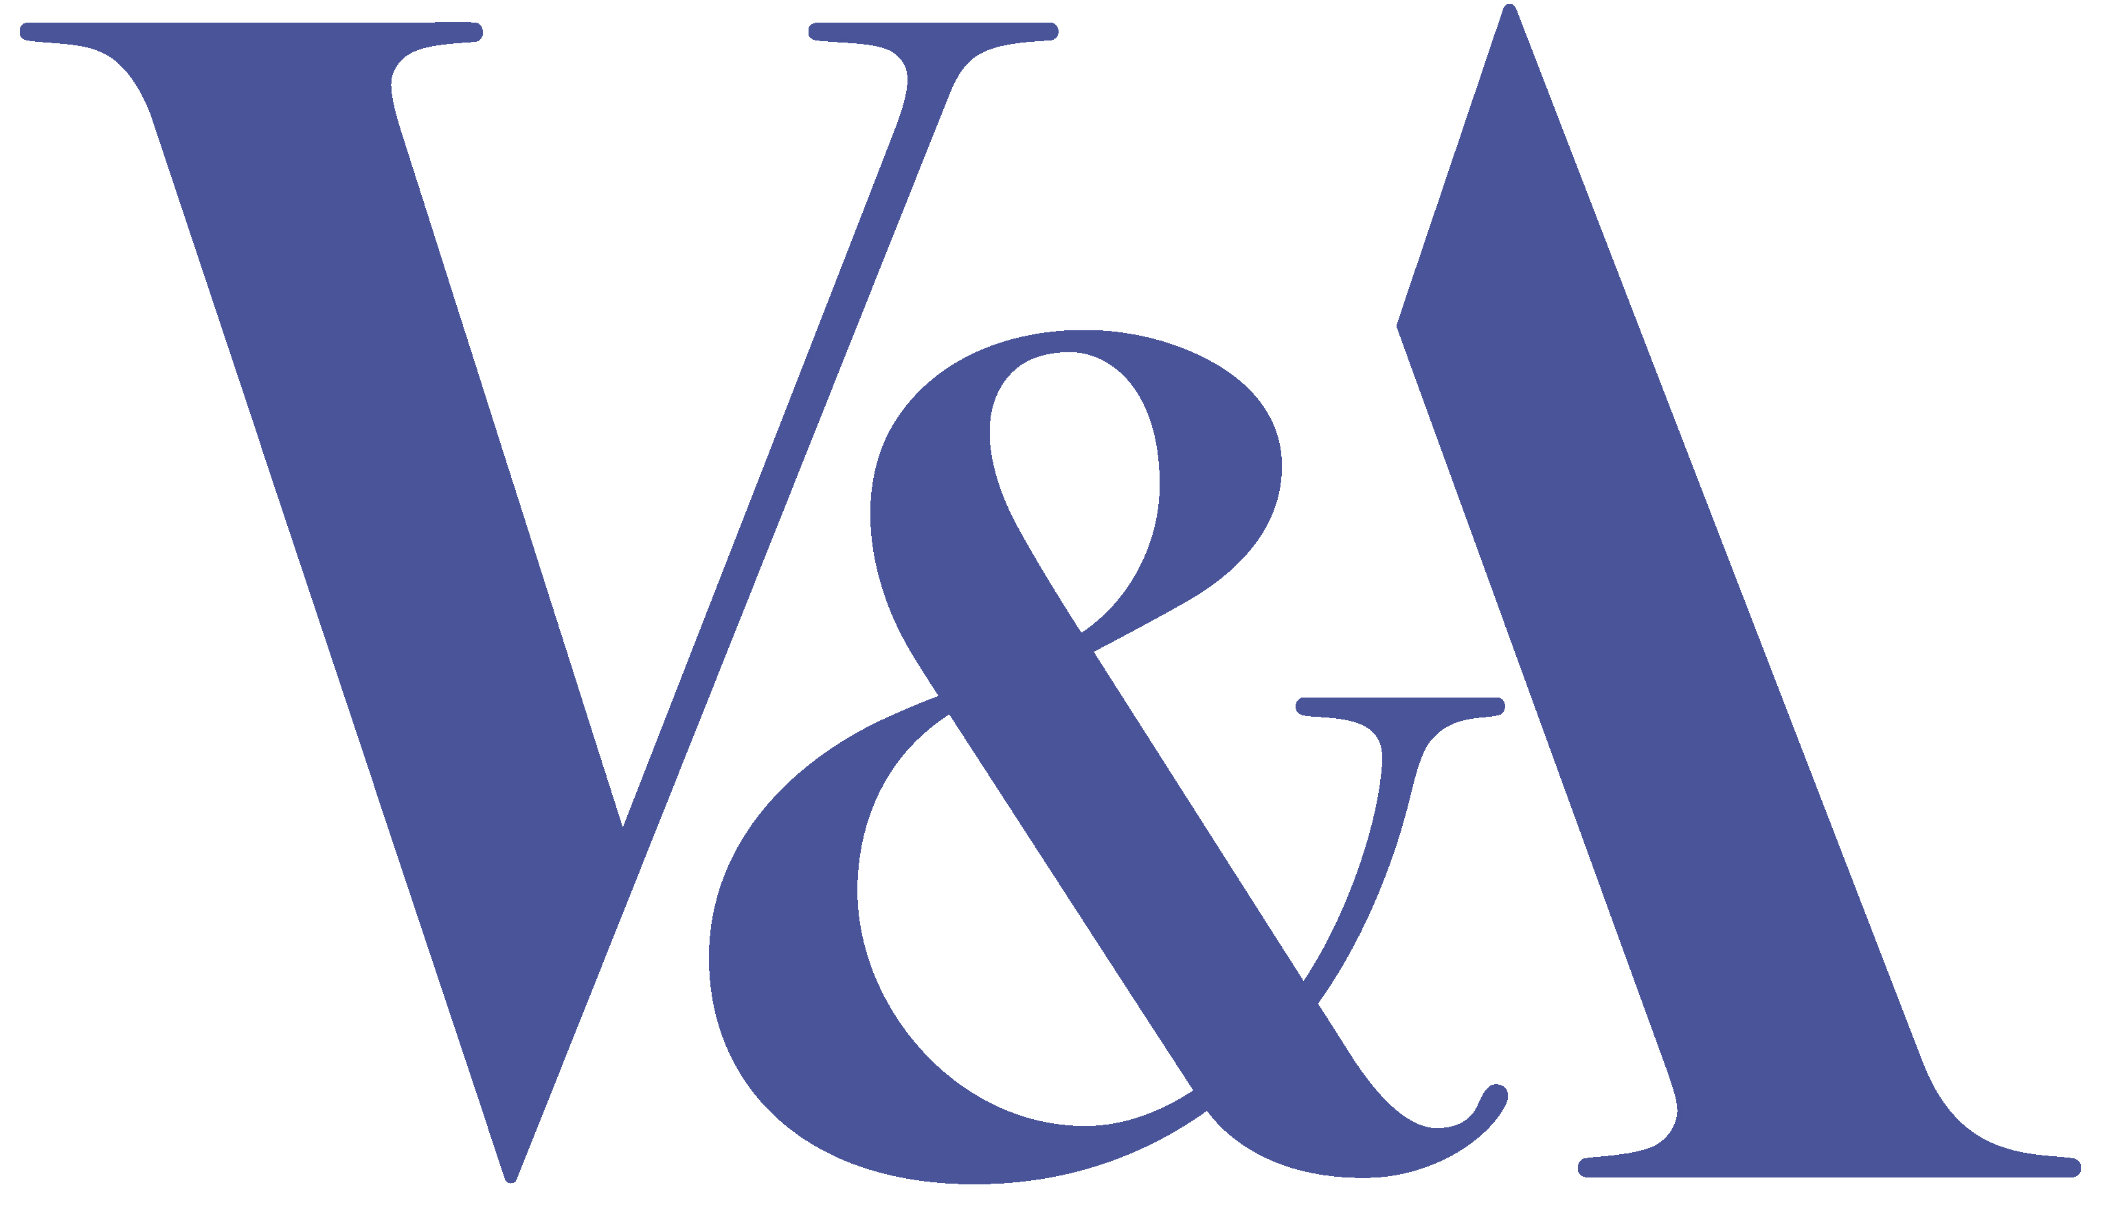
VICTORIA AND ALBERT MUSEUM
DEVELOPMENT DEPARTMENT

Post: 2 x Corporate and Private Events Managers
(1 x Full time, Permanent)
(1 x Full Time, 12 month fixed term maternity cover)
Department: Development
Reporting to: Head of Corporate and Private Events
Salary: £29,000 – 31,000 dependent on experience
Application deadline:

BACKGROUND
The magnificent Victorian gallery spaces and stunning John Madejski Garden make the Victoria and Albert Museum one of London’s most prestigious venues. Reflecting its reputation as the world’s greatest museum of art and design, the V&A’s magnificent South Kensington building is itself a unique gem of Victorian architecture. A treasure house teeming with collections of fabulous scope and diversity, the Museum boasts extraordinary rooms and spaces which offer exceptional
possibilities for entertaining in a prestigious central London location.

The Victoria and Albert Museum has a vacancy for two experienced Corporate and Private Events Managers, working within a well-established team, to promote the V&A as a venue for corporate and private hire and to ensure efficient and effective supervision of commercial hire events while maximising income and monitoring costs.

KEY RESPONSIBILITIES
- To ensure the efficient and effective management and delivery of Corporate Events at the V&A.
- To ensure the satisfaction and enjoyment of clients and guests, consistent with the reputation of the V&A, its Corporate Events offer and approach to client management
- To meet annual income targets, together with the support of the rest of the Corporate Events Team.
- To ensure the appropriate and sympathetic use of the Museum for events and ensure clear communication and build on good relations with Museum staff.
- To assist Corporate Partnerships colleagues with the identification and cultivation of prospective Corporate Members and Sponsors in order to maximise revenue for the Museum in the long term.

SPECIFIC DUTIES:
- To answer event enquiries, undertake site visit and oversee events to a high standard
- To deliver full and effective supervision of all contractors (e.g. caterers, florists, lighting and production companies), ensuring all procedures and guidelines are available and understood.
- To ensure that the Museum is treated with respect, that Health & Safety guidelines are adhered to, and that the Museum is returned to normal for the public after each event.
- To treat clients, guests, contractors and colleagues with respect and professionalism, ensuring that the reputation of the V&A brand and its commercial events business are upheld at all times.
- To escort potential new clients around the Museum, ascertaining their requirements and tailoring these to what the V&A can provide from the range of options available.
- To liaise with Museum colleagues and use published information sources to ensure accurate information on any gallery re-fits, closures, access, opening policies etc. that may impact on the successful delivery of events.
- To be well informed of the Museum’s Public Programme including knowledge of forthcoming exhibitions.
- To attend meetings with clients to discuss confirmed bookings and meeting on site with contractors.
- To ensure that the Development Department’s database, Raiser’s Edge, is kept up to date with details of events clients and prospects and maintain documentation, invoicing, correspondence, marketing and mailings.
- To respond to incoming email and telephone enquiries within a set time frame.
- To actively inform and promote Corporate Membership to events clients and prospects and build awareness of sponsorship opportunities as appropriate.
- To work in liaison with Corporate Partnership colleagues to promote corporate event opportunities to current Corporate Members and Sponsors.
- To identify any Corporate Membership and Sponsorship prospects to be invited to cultivation events and to manage the logistics for any cultivation events hosted by the Corporate team.
- To notify colleagues in the Development office of any individual event contact with the potential to become Friends or Director’s Circle Members.

GENERAL:
- General assistance, where required, with the work of the Development team. Special projects may also be set according to workload capacity and the skills of the individual.
- attendance at appropriate events outside normal working hours
- Be committed to health and safety and ensure familiarity with all of the Museum's health and safety policies and procedures
- Be security conscious, ensure familiarity and co-operation with all museum security procedures and ensure you wear a security pass at all times when on museum premises
- Work within Departmental guidelines on computer security, record-keeping and data protection (Data Protection Act)
- Promote equality and diversity in all aspects of your work by developing and maintaining positive working relationships, ensuring that colleagues are treated fairly and with respect/dignity and actively contributing to developments that support the Museum’s strategy for widening access, inclusion and diversity
- The post will require evening and early morning work, including running morning and evening events and assistance at exhibition openings. Standard hours are Monday to Friday, 09.00 – 17.30.

PERSON SPECIFICATION
The successful candidates must be able to demonstrate the following:
Essential
- Solid and demonstratable experience in a comparable role
- Highly professional, confident with a positive, ‘can-do’ attitude
- Excellent communication skills: proficient at managing caterers and other event suppliers
- Excellent planning and time management skills: good at working under pressure, prioritising and managing multiple requirements
- Ability to be a team player, both within the Corporate Events team and the wider Development Department
- Excellent written and verbal communication skills with exceptional attention to detail
- Availability to work outside usual office hours
- Interest and commitment to the work of the Victoria and Albert Museum

Desirable
- Previous experience of delivering events within an arts/heritage venue
- Experience using Raiser’s Edge Database
- An understanding of fundraising including corporate membership schemes and sponsorship
- Knowledge and understanding of Health and Safety obligations

APPLICATION DETAILS

Please email a copy of your CV and a one-page covering letter outlining your suitability for the role to Dragicca Carlin at development@vam.ac.uk Please include the code DEV-EVENTS PERM (for the Permanent position) or DEV-EVENTS CONTR (for the fixed term position) in the subject header of the email.

Interviews will take place in mid to late November. We regret that we can only notify successful candidates of interviews. If you have not heard from us by then, please consider your application unsuccessful.

